1132 - Summing up Powers:
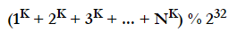
Given N and K,(1≤N≤10¹⁵) and (0≤K≤50). you have to find-

Solution:

Now, from the right hand of [1], we can see that f(x) is a recurrence relation, and f(x+1) is already defined from known expressions. What is not so apparent, is the second expression. How to calculate (x+2)^{k} from the expressions we have?
We’ll, let’s start by expanding the expression. Thanks to Pascal Triangle. we know that expanding the binomial (x+1)^{k} produces the following:

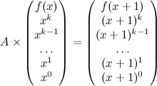
This looks better. Now we have a set of binomial coefficients, and a set of expressions of the form x^{i}, which have recurrence, meaning that we could calculate (x+1)^{i} using the expressions we have already. Now let’s put this in matrix form.

And knowing what we know, fill the matrix of coefficients:
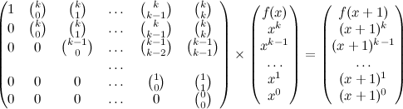

Sample Code:

#define ll long long int
#define mod 4294967296
ll c[60][60],d;
struct matrix
{
ll v[55][55];
int row,col;
};
void nCr() //Pascal Triangle
{
memset(c,0,sizeof(c));
for(int i=0; i<55; i++) c[i][0]=1;

for(int i=1; i<55; i++)
{
for(int j=1; j<=i; j++)
{
c[i][j] = c[i-1][j-1] + c[i-1][j];
c[i][j] %= mod;
}
}
}
matrix multiply(matrix x, matrix y)
{
matrix r;
r.row=x.row; r.col=y.col;

for(int i=0; i<r.row; i++)
{
for(int j=0; j<r.col; j++)
{
ll sum=0;
for(int k=0; k<x.col; k++)
{
sum+=x.v[i][k]*y.v[k][j];
sum%=mod;
}
r.v[i][j]=sum;
}
}
return r;
}
matrix power(matrix mat, ll p)
{
matrix res;
res.row=res.col=d;

for(int i=0; i<d; i++)
for(int j=0; j<d; j++)
res.v[i][j]=0;

for(int i=0; i<d; i++)
res.v[i][i]=1;

for(ll i=p; i>0; i/=2)
{
if(i%2==1) res = multiply(res,mat);
mat = multiply(mat,mat);
}
return res;
}
int main()
{
nCr();

int t;
scanf("%d",&t);

for(int kase=1; kase<=t; kase++)
{
ll n,k;
scanf("%lld%lld",&n,&k);

if(n==1){
printf("Case %d: 1\n",kase);
}
else
{
d=k+2;
matrix mat;
mat.row=mat.col=d;

for(int i=0; i<d; i++)
for(int j=0; j<d; j++)
mat.v[i][j]=0;

for(int i=0; i<d; i++)
mat.v[i][i]=1;

for(int i=1; i<d; i++)
mat.v[0][i]=c[k][i-1];

for(int i=1,x=k; i<=k; i++,x--)
for(int j=i+1,y=1; j<d; j++,y++)
mat.v[i][j]=c[x][y];

mat = power(mat,n-1);
ll fn=0;
for(int i=0; i<d; i++){
fn += mat.v[0][i]; fn %= mod;
}
printf("Case %d: %lld\n",kase,fn);
}
}
return 0;
}

